PeopleDesk
HR Policy Knowledge Assistant
RAG Chatbot — Project Report

Workflow implementation using n8n and Ollama

Project overview
PeopleDesk adapts the supplied CyberON cybersecurity RAG chatbot reference into an HR-domain knowledge assistant. The intended chatbot retrieves relevant passages from HR policy documents and uses them to answer employee questions.

Report note
This report follows the reference PDF's structure: document insertion, workflow architecture, chatbot interface, sample user query, response, technical query, and memory follow-up. Screenshot spaces are placeholders for replacement with the project's own HR workflow and test results.

1. Inserting HR Documents into the Simple Vector Store Database
The knowledge base should contain HR documents such as leave policy, attendance policy, onboarding guidelines, and employee benefits information. These may be approved public documents or clearly labelled fictional documents created for the assignment.
Sample document | Content to include
01_Leave_Policy.pdf | Leave categories, eligibility, application process, notice requirements, and approval steps.
02_Attendance_Policy.pdf | Working hours, attendance recording, late arrivals, and attendance regularization.
03_Onboarding_Guide.pdf | Joining formalities, documents required, induction, and employee setup.
04_Benefits_Policy.pdf | Employee benefits, eligibility criteria, claims, and conditions.

The document-ingestion path should load the files, extract text, generate embeddings, and insert the resulting document chunks into the Simple Vector Store. The data loader and embedding connections must be checked in n8n to confirm that indexing is actually performed.
Figure 1. HR document insertion workflow
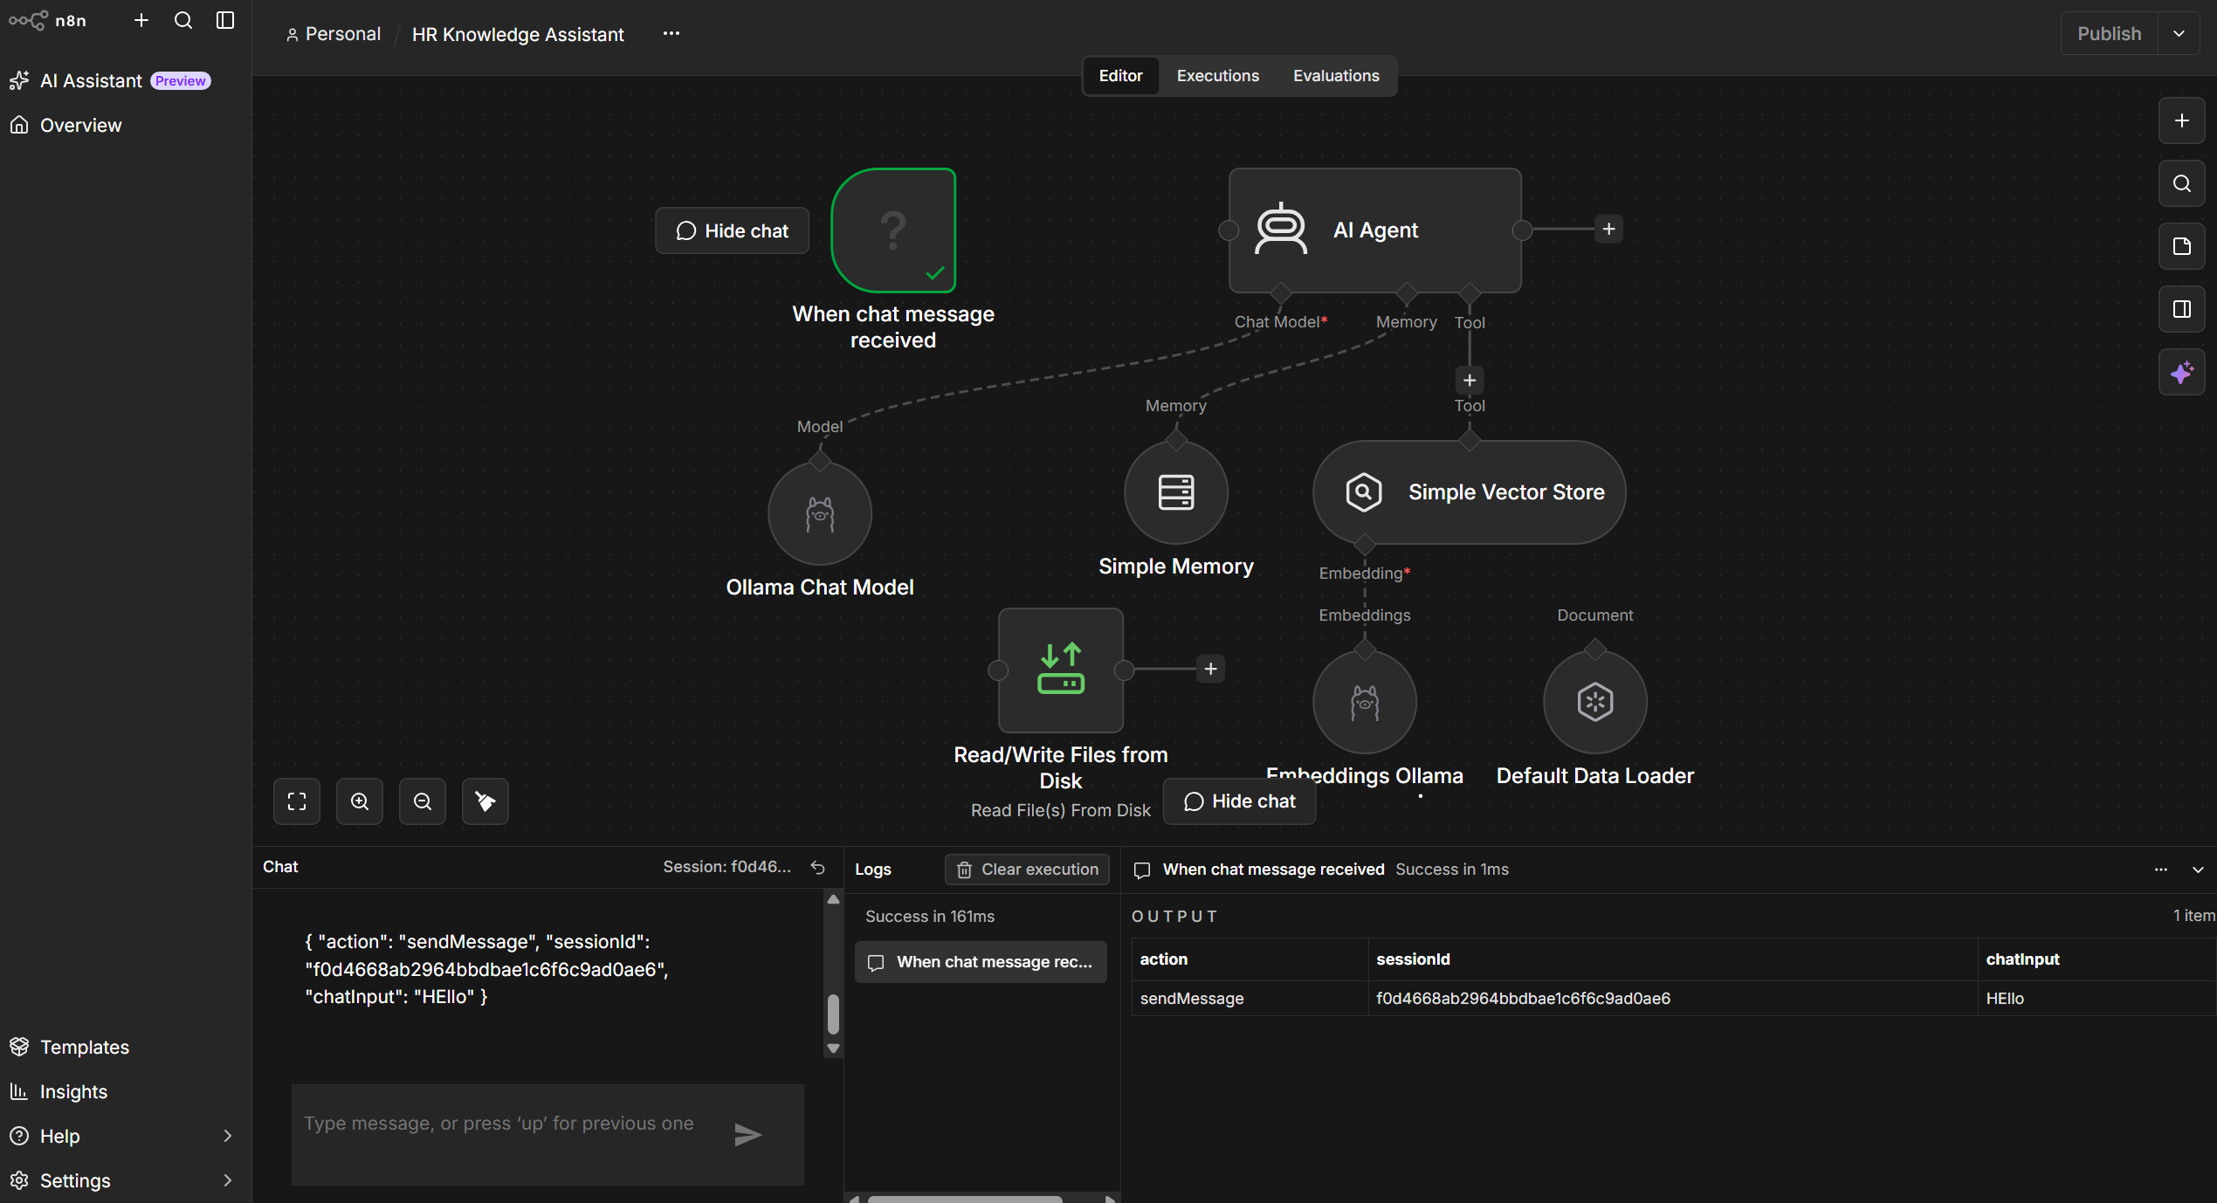
Figure 2. Vector store insertion settings
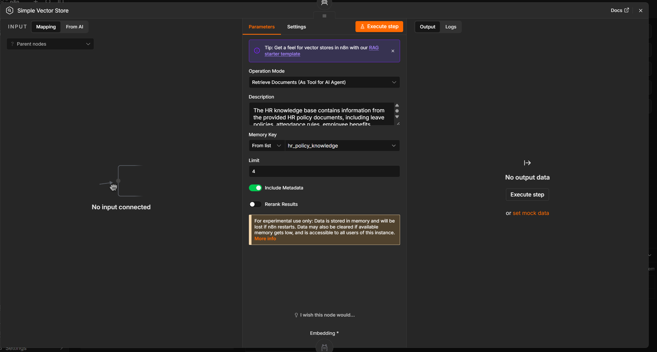

2. Workflow Architecture
The planned workflow follows the reference design: a chat trigger sends the employee's message to an AI Agent, which can query the Simple Vector Store as a retrieval tool. The agent uses an Ollama chat model to formulate an answer and Simple Memory to support follow-up questions.
When chat message received → HR Policy Assistant
├─ Chat Model: Ollama
├─ Memory: Simple Memory
└─ Tool: Simple Vector Store (HR policy retrieval)
Document ingestion: HR files → Default Data Loader → Ollama Embeddings → Simple Vector Store
Node / component | Function
When chat message received | Starts the workflow when an employee submits a question.
HR Policy Assistant (AI Agent) | Understands the question, retrieves supporting content, and prepares the answer.
Ollama Chat Model | Runs the local language model used to generate the response.
Simple Memory | Keeps conversational context for follow-up questions.
Simple Vector Store | Stores document vectors and retrieves relevant HR content.
Ollama Embeddings | Creates vector representations of HR document chunks and queries.
Default Data Loader | Loads documents and metadata for indexing.
Read/Write Files from Disk | May be used for file handling if configured and connected to the ingestion path.

Implementation note: the supplied reference states that its chatbot worked while the Groq model briefly reached its token limit. PeopleDesk uses a local Ollama model as the intended alternative; successful connectivity and execution must be verified before claiming the HR chatbot is fully functional.
Figure 3. PeopleDesk workflow architecture

3. Chatbot Interface
The chat interface is the employee-facing entry point. It should use HR-focused wording so users understand the assistant's scope.
UI element | Suggested text
Chatbot title | PeopleDesk — HR Policy Assistant
Subtitle | Ask questions about HR policies and employee procedures.
Initial greeting | Hi! I'm PeopleDesk, your HR Policy Assistant. Ask me about leave, attendance, onboarding, benefits, or workplace policies.
Input placeholder | Ask an HR policy question...
The response should be concise, grounded in retrieved policy content, and include a source document name when the retrieval metadata makes it available. If the policy does not state an answer, the assistant should say so and recommend checking with HR.
Illustrative response format:
“According to the uploaded [policy document], [summarize only the rule supported by the retrieved passage]. The document also states [relevant condition, if present]. Please contact HR if you need confirmation for an exception.”
This is a response template, not a claim about the contents of a particular HR policy. Replace it with the actual output captured during testing..

4. Model, Embeddings, and Memory Configuration
Component | Intended configuration
Ollama chat model | llama3.2:latest, if selected and available in n8n.
Ollama endpoint | http://127.0.0.1:11434 when n8n and Ollama run directly on the same Windows host; other environments may require a different host address.
Embedding model | nomic-embed-text:latest.
Simple Memory | Use the chat session identifier so follow-up turns share context.

A previous attempt produced ECONNREFUSED ::1:11434. For a direct Windows setup, test the IPv4 loopback URL above and verify that Ollama is running. If n8n is containerized, localhost refers to the container and the correct host address must be configured.
Figure 10. Ollama chat model and embedding configuration
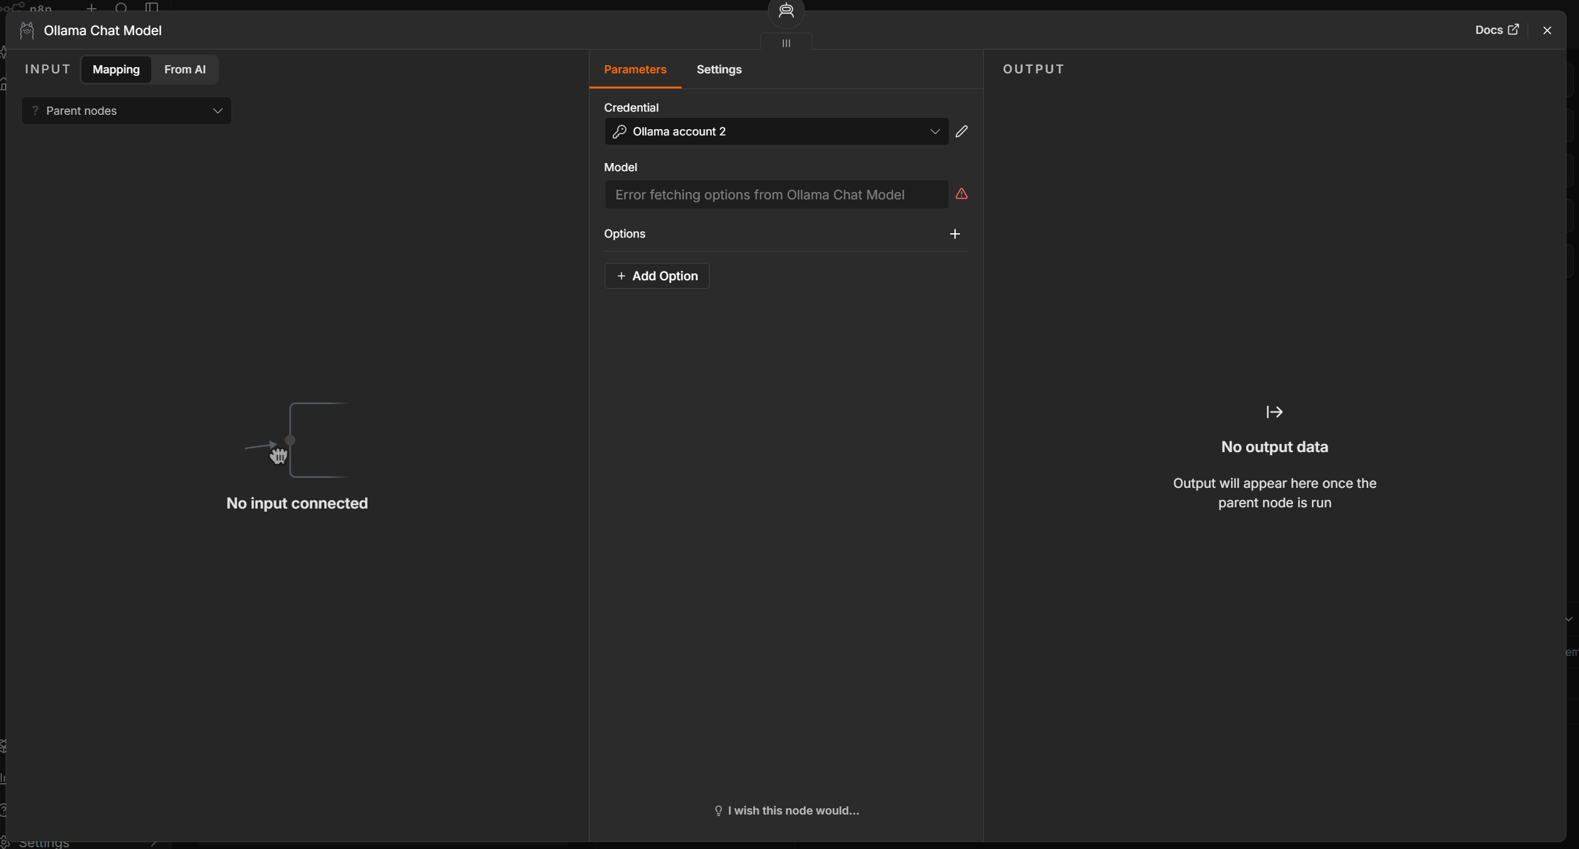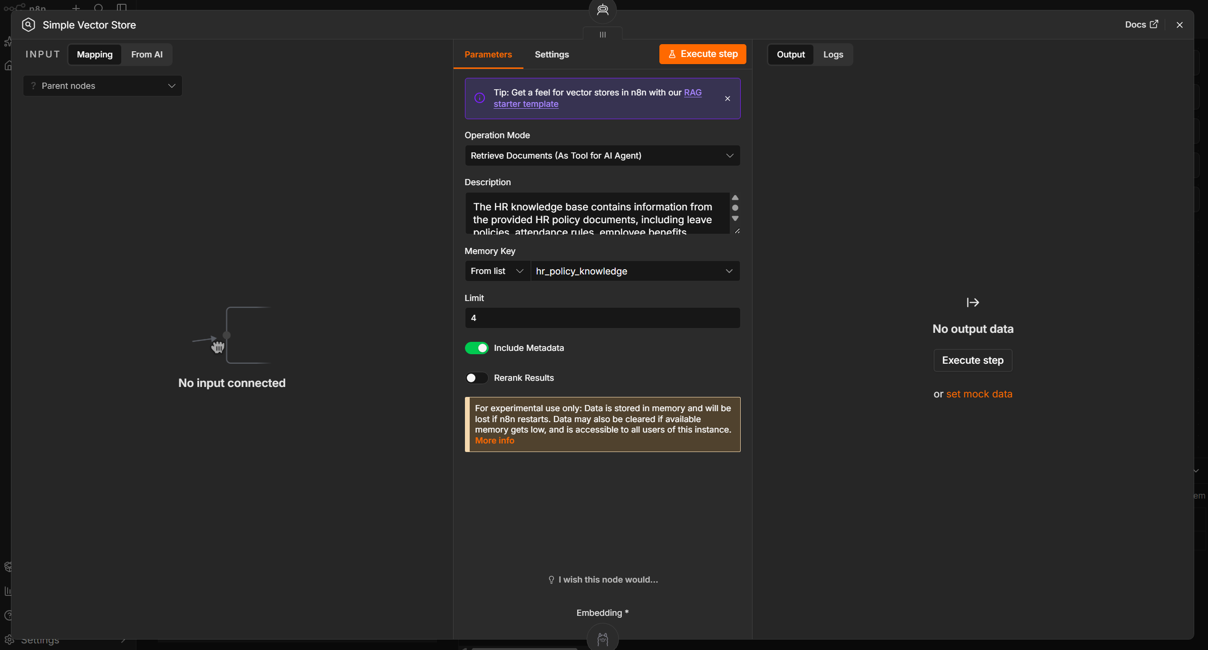

Figure 11. Simple Memory configuration
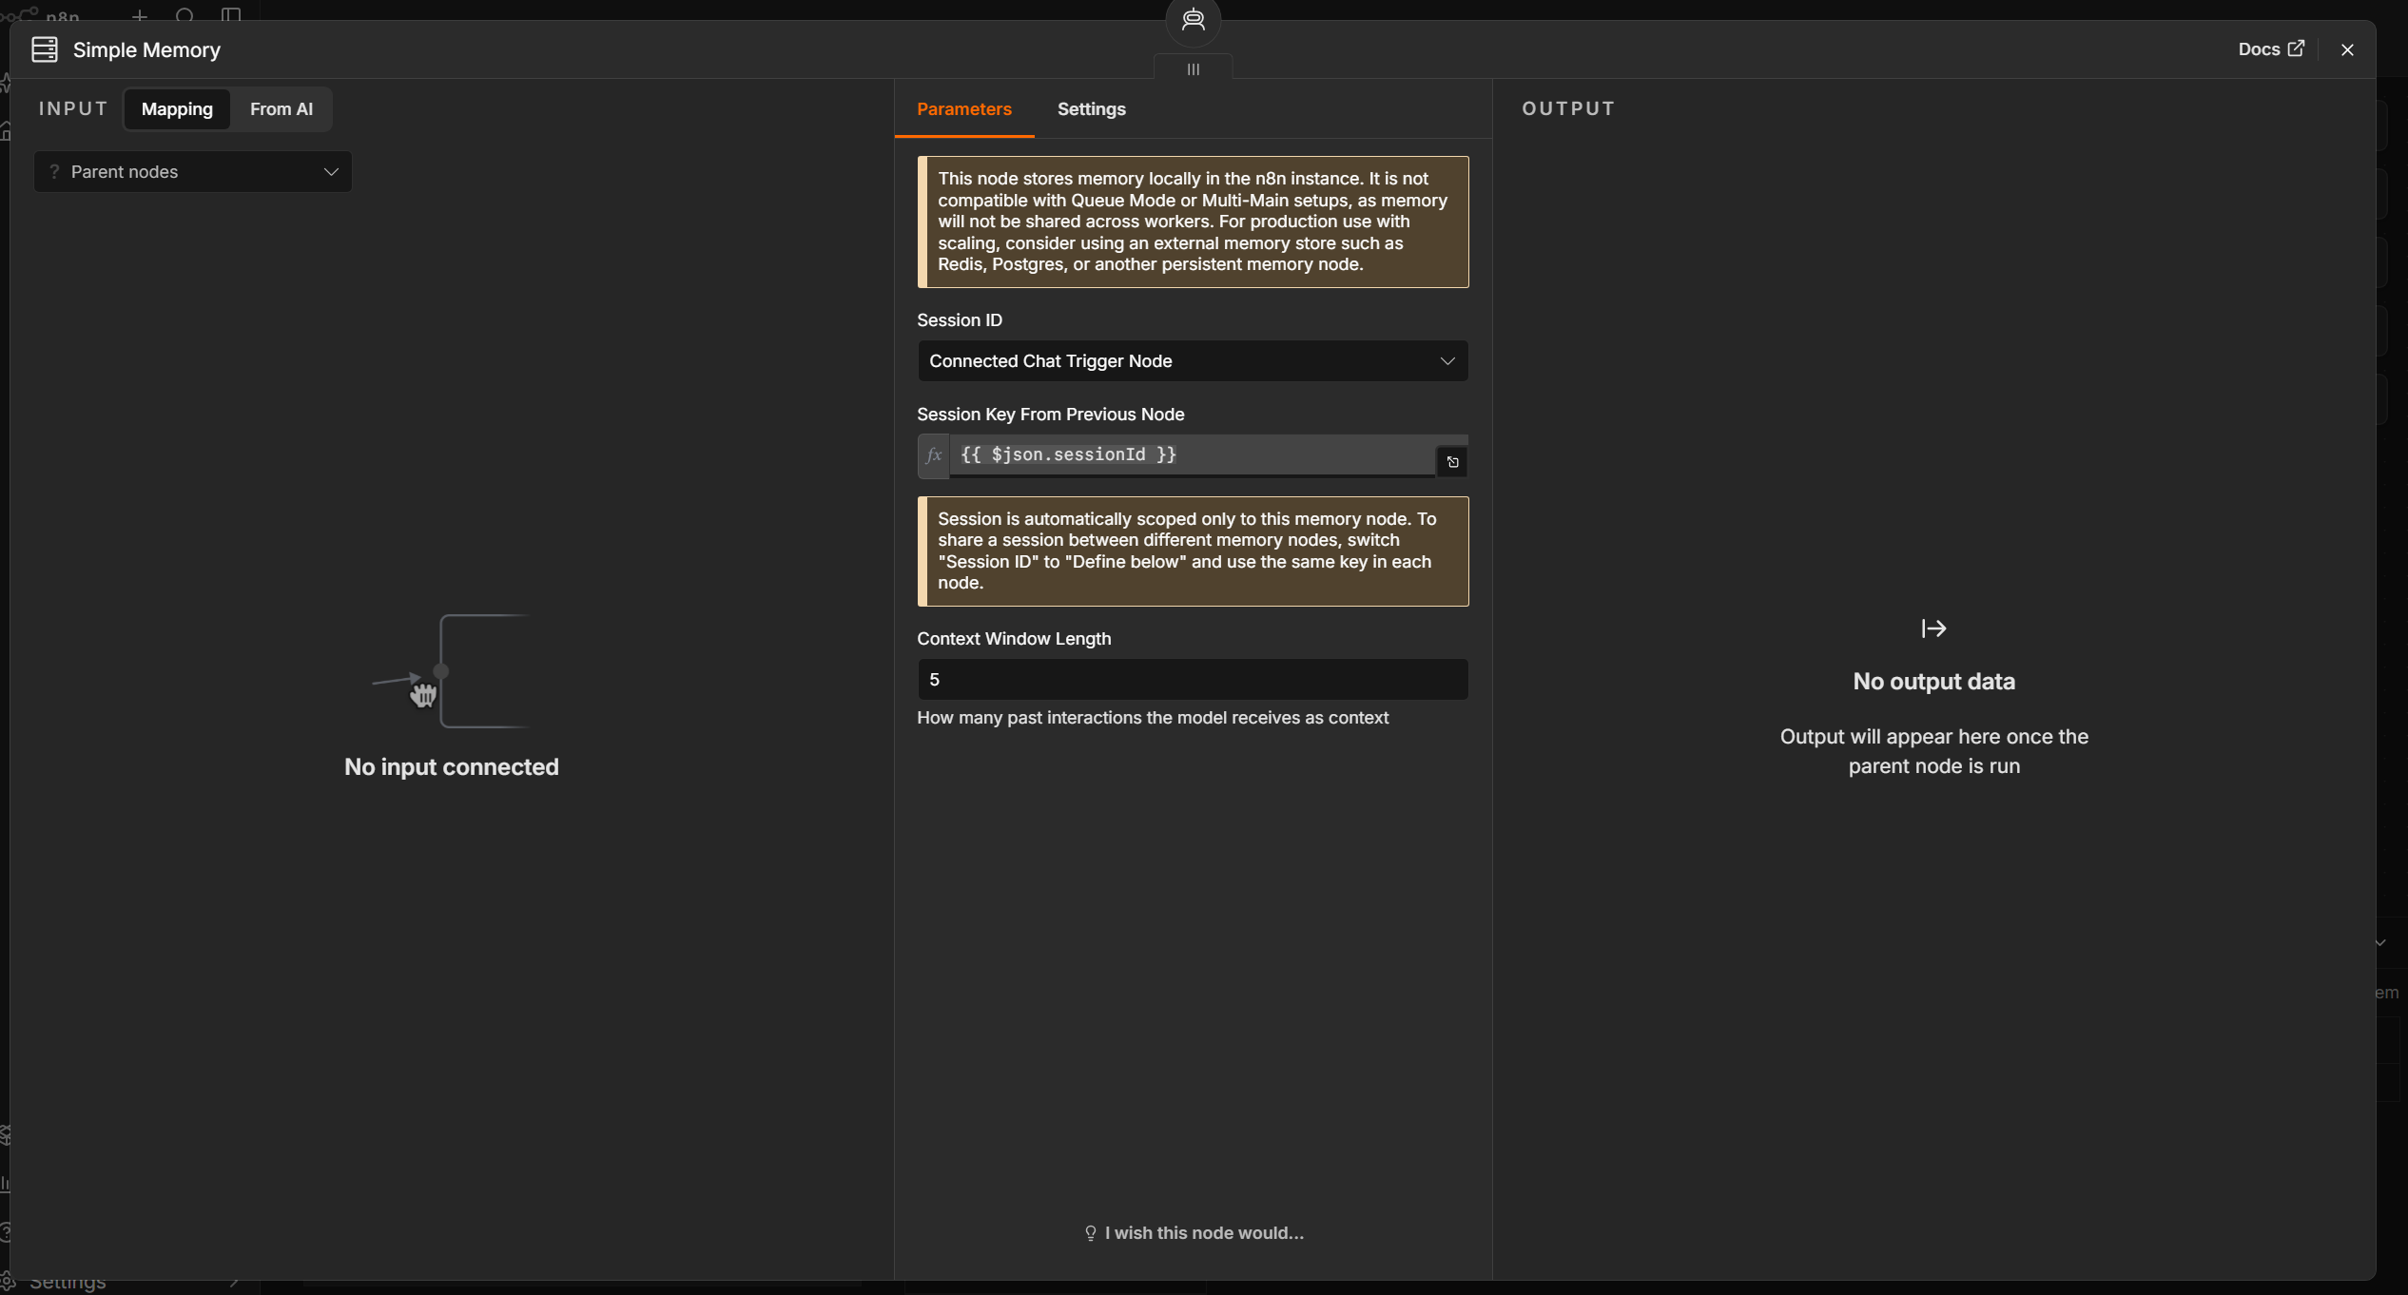

10. Testing and Implementation Status
Test case | What it verifies | Status
HR document indexing | Documents are loaded and stored under the HR key. | Pending validation
Simple policy query | Relevant policy text is retrieved and summarized. | Pending validation
Detailed procedural query | Multiple relevant details are retrieved without invention. | Pending validation
Follow-up question | Chat session memory resolves a contextual follow-up. | Pending validation
Missing information | Assistant acknowledges when the knowledge base does not support an answer. | Pending validation
End-to-end workflow | Chat trigger, model, retrieval, and response complete without errors. | Pending validation

The supplied CyberON reference shows document insertion into the Simple Vector Store (page 1), the workflow canvas and a note about a temporary Groq token-limit issue (page 2), the chat interface and first query (page 3), a response and more technical query (page 4), and a memory follow-up (page 5). This report follows that same demonstration sequence for PeopleDesk.

Conclusion
PeopleDesk adapts the reference RAG chatbot structure to HR policy assistance. The planned demonstration should show HR document insertion, the full workflow architecture, the chat interface, a simple query and response, a detailed query, and a contextual follow-up. The report is a draft until the HR documents are indexed and each test is captured from the working n8n workflow.

